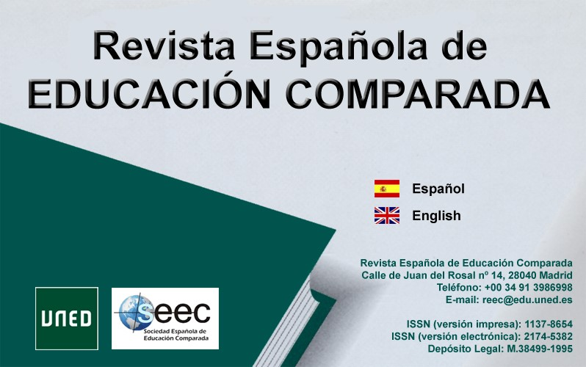
MONOGRAPHIC PROPOSAL FORM FOR THE REVISTA ESPAÑOLA DE EDUCACIÓN COMPARADA, REEC.
(After completing, send to reec@edu.uned.es)
Title of the
Monographic

Justification of suitability to the “thematic profile”of the
REEC

Guest
Editors

(with their affiliation, email and a brief resumé)

CONTENT AND
RELEVANCE
(contribution to comparative epistemology, antecedents of the proposal)

Possible
authors

Possible
reviewers

 | GENERAL CONSIDERATIONS
Languages | Works may be in Spanish or in English.  (exceptionally, manuscripts in French and Portuguese may be accepted).
Editorial norms | Articles must satisfy the norms (“Guidelines for authors”) of the Revista Española de Educación Comparada, REEC, for the presentation of original manuscripts, which may be consulted here: http://revistas.uned.es/index.php/REEC/about/submissions#authorGuideli nes
Submission of articles | Authors should send their articles to the Revista Española de Educación Comparada, REEC, and to the guest editors.  For sending articles to the REEC, authors should use the UNED’s platform “Plataforma de Gestión de Revistas”.  (http://revistas.uned.es/index.php/REEC/about/submissions#onlineSubmi
ssions)

For sending articles to the guest editors, authors should use the email addresses included in this form.

For any doubts or clarifications relating to this convocation please call the telephone number +34 91 398 6998 or write to the following email address: reec@edu.uned.es

Review and selection of manuscripts | Once the external peer review process has been completed, the guest editor or editors, together with the Editorial Board of the REEC, will decide which articles from among those having received a positive evaluation will be published in the Monographic issue.  The REEC will inform the authors of the acceptance or rejection of their articles.

Date | CALENDAR
 | Date from which original manuscripts are accepted.
 | Deadline for the reception of manuscripts.

