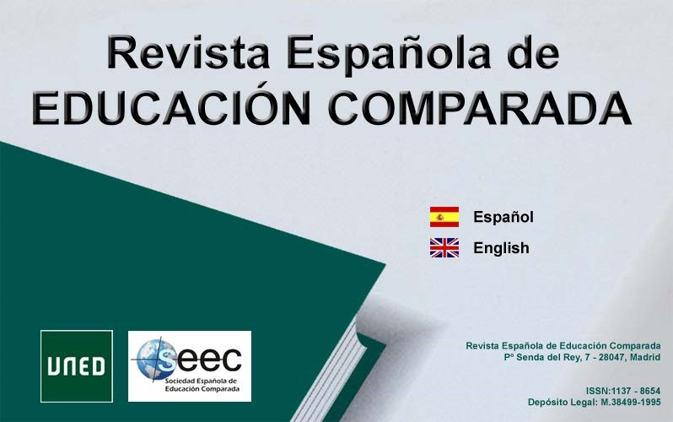

ISSN (print version): 1137-8654
ISSN (electronic version): 2174-5382

Formal evaluation of original manuscripts

Intended for the Editorial Staff, in order to verify that the original manuscript conforms to the journal’s formal characteristics.

Issue:
Title:

- Is the word count between 5,500 and 7,000 words? Yes No

- Does it conform to the publication’s format? Yes No

- Is the summary presented in the IMRYD format? Yes No

- Does the word count of the summary conform to publication guidelines (250 – 300 words)?
Yes No

- Are the title, keywords and summary properly translated? Yes No

- Are the bibliographical references in the text cited properly? Yes No

- Are charts, graphs and images used appropriately within the text? Yes No

- Are the notes (footnotes) organized properly? Yes No

- Are the keywords taken from the ERIC Thesaurus? Yes No

- Is there a maximum of 6 keywords? Yes No

11. Do they conform to the APA guidelines? Yes No

- Of the references cited in the text, do at least 30% of them date from the last four years? Yes No

- Has this work been published anywhere else, in any format? Yes No. If affirmative, indicate: Wholly Partially

- Is the article’s subject/approach in keeping with the requirements of the publication’s editorial line? Yes No

- Are the author/s’ academic and professional profile/s included (between 50 and 75 words) ? Yes No
2

